
Final Group Project Report
Port Authority Bus Terminal Project
Group 4 - BANL 6430 -06

Report by Group-4 ( Team Members ) :
Narapareddy Venkata Jyoshna | Coding, Analysis and data preparation part for 3,4 & 5 goals, Recommendations, PPT Preparation, Presentation and Final Report Preparation.
Pooja Dilip Talikoti | Project Goal 1 Data part , Dashboarding & Insights and Final Report Preparation
Mythri Potluri | Project Goal 2 Data Part, Dashboarding & Insights
Srija Sripalli | Project Goal 3 Dashboarding, Insights
Nehitha Reddy Aramati | Project Goal 4 Dashboarding, Insights
Mansi Jain | Project Goal 5 Dashboarding, Insights

We have been given 4 questions to be answered for all the 5 goals :
1. Project the number of passengers for the bus terminal from 2025 to 2030.

Important Variables:
The most critical variables for projecting the number of passengers are Date and Total Passengers. The date variable is essential because it allows the model to recognize time-dependent patterns, trends, and seasonality in the data. Additionally, incorporating variables that capture special events, holidays, or seasonal effects can significantly enhance the accuracy of passenger forecasts.

Dependent Variable:
The dependent variable in this analysis is Total Passengers. We aim to forecast passenger numbers for future years based on historical data from 2020 to 2024. Passenger count is chosen as the dependent variable because it directly represents the volume of travelers that the bus terminal needs to accommodate, making it the primary focus for resource planning and capacity management.

Recommendations:
To improve forecast accuracy, it is recommended to address potential data gaps and inconsistencies in the historical dataset, especially for periods affected by external disruptions (e.g., COVID-19). Incorporating additional data, such as special events, weather anomalies, or economic factors, could help the model better account for variations in passenger volume. It is also advisable to validate the model regularly as new data becomes available to ensure continued relevance.

Models and Techniques:
We used the ARIMA Model for time series forecasting, given its effectiveness in modeling time-dependent data with seasonality and trend components.
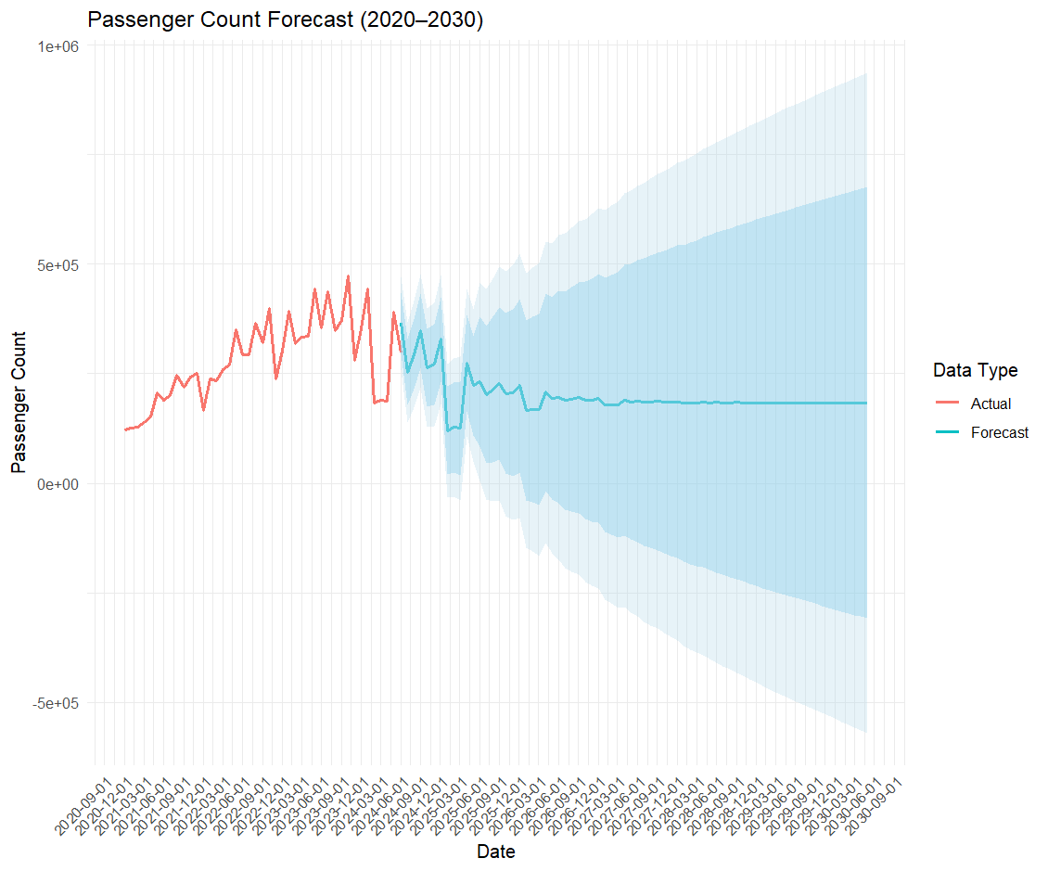

Passenger Count Forecast (2020–2030) using ARIMA with confidence intervals.
This chart shows actual and forecasted passenger counts using an ARIMA model. Forecasts remain steady beyond 2023, with widening confidence intervals indicating greater uncertainty over time

Tools Used:
Final Data is stored in excel, data cleaning and preprocessing is done in Power BI. The analysis was conducted using R, leveraging libraries like forecast, ggplot2, dplyr, and openxlsx. Power BI is used for dashboarding.

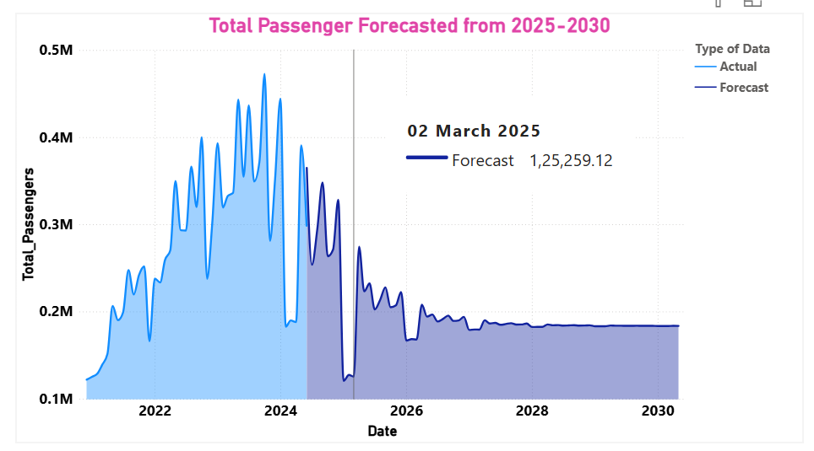

Forecast of Total Passengers from 2025 to 2030 based on historical trends.
The chart forecasts total passengers from 2025 to 2030 using historical data from 2020 to 2024, with "Total Passengers" as the dependent variable. Forecasts suggest a decline and stabilization in passenger volume, with 1,25,259.12 passengers projected on March 2, 2025. Time trends and seasonal effects play a key role, and forecast accuracy can improve by addressing data gaps and including external factors like events and weather.

2: Identify the most important factors affecting the number of passengersImportant Variables:
Key variables impacting passenger numbers include Snow Depth (SNWD), Maximum Temperature (MAX_Temp), Minimum Temperature (MIN_Temp) and Average Wind (AWND). These weather-related variables are crucial as they directly influence travel behavior.

Dependent Variable:
The dependent variable is Total Passengers, as the primary goal is to understand how various environmental factors influence the volume of bus terminal users. This variable represents the actual count of passengers affected by changes in weather and other conditions, making it essential for analyzing travel patterns and optimizing operational strategies.
Recommendations:
To improve the reliability of the model, it is crucial to address missing data within weather variables, which may arise due to sensor errors or recording inconsistencies. Using imputation methods like mean substitution or regression-based filling can help maintain data continuity. Including contextual variables such as major local events or traffic disruptions could further improve prediction accuracy.
Models and Techniques: We employed a Multiple Linear Regression Model to quantify the effect of various weather parameters on passenger numbers.
Tools Used: Final Data is stored in excel, data cleaning and preprocessing is done in Power BI. The analysis utilized R, with packages such as dplyr, forecast, and openxlsx for data manipulation and model creation. Power BI is used for dashboarding.

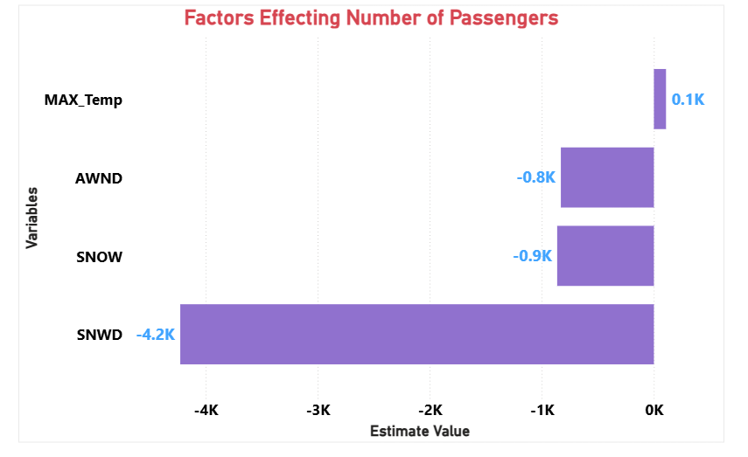

Impact of Weather Variables on Passenger Numbers – Snow Depth (SNWD) shows the strongest negative effect.
Weather factors like snow depth, snowfall, and wind speed negatively impact passenger numbers, while maximum temperature has a slight positive effect. Snow depth is the most influential variable, significantly reducing travel volume

3: Project prediction results by individual carrier :
Important Variables:
The key variables include Date, Total Passengers, and Carrier Name. Each carrier (e.g., NJ Transit, Trailways) has unique operational patterns that affect passenger volume. Including carrier-specific data is essential as different carriers have varying peak periods and seasonal usage.
Dependent Variable:
The dependent variable is Total Passengers per Carrier, as the goal is to project the number of passengers using each bus service. This differentiation helps identify which carriers are likely to experience higher demand, enabling targeted planning for infrastructure and service improvements.
Recommendations:
It is essential to ensure consistent data collection across all carriers to avoid skewed results. Including carrier-specific factors such as service frequency or route popularity could enhance prediction accuracy. Regularly updating the model with new data will help maintain accuracy, as carrier usage patterns can shift due to external factors like policy changes or service modifications.
Models and Techniques:
We utilized the ARIMA Model for each carrier to generate passenger count forecasts by individual carrier, analyzing trends and seasonal variations.
Tools Used:
Final Data is stored in excel, data cleaning and preprocessing is done in Power BI. The implementation was done in R, utilizing libraries like dplyr, ggplot2, forecast, and openxlsx for analysis and visualization. Power BI is used for dashboarding.

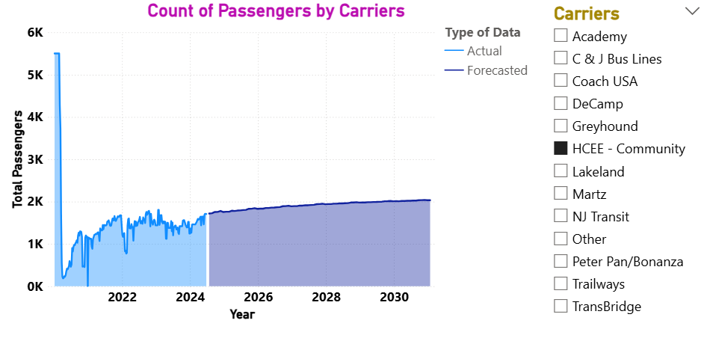

Passenger Trends and Forecasts for HCEE - Community Carrier (2020–2030)
The chart displays actual and forecasted passenger counts for different carriers. The ARIMA model was used to predict future demand, supporting data-driven transit planning.

4: Identify the busiest times for the bus terminal staging facilities between 2025 and 2030 :
Important Variables:
The most significant variables identified for determining the busiest times are Date, Total Buses, and Facility Name. The Date variable helps capture temporal patterns such as seasonal peaks and yearly trends, while Total Buses per facility provides insights into the volume of traffic handled by each location.
Dependent Variable:
The dependent variable in this analysis is Total Buses per Facility. The goal is to predict the volume of buses at each facility over time to identify peak usage periods. Understanding bus volume trends helps in planning staffing levels, optimizing resource allocation, and ensuring that the terminal infrastructure is capable of handling high traffic loads during peak periods.

Recommendations:
To enhance the accuracy of identifying peak times, it is recommended to include external factors such as major event dates, holiday schedules, and seasonal fluctuations. Facility usage can vary significantly based on external influences like special events or changes in public transportation policies. Incorporating real-time data from sensors or automated ticketing systems can provide more granular insights into peak traffic hours.
Models and Techniques:
We applied the ARIMA Model to forecast bus by individual facility, focusing on capturing seasonal patterns and peak periods.
Tools Used:
Final Data is stored in excel, data cleaning and preprocessing is done in Power BI. Analysis was carried out using R, with key libraries including lubridate, dplyr, forecast, and ggplot2. Power BI is used for dashboarding.

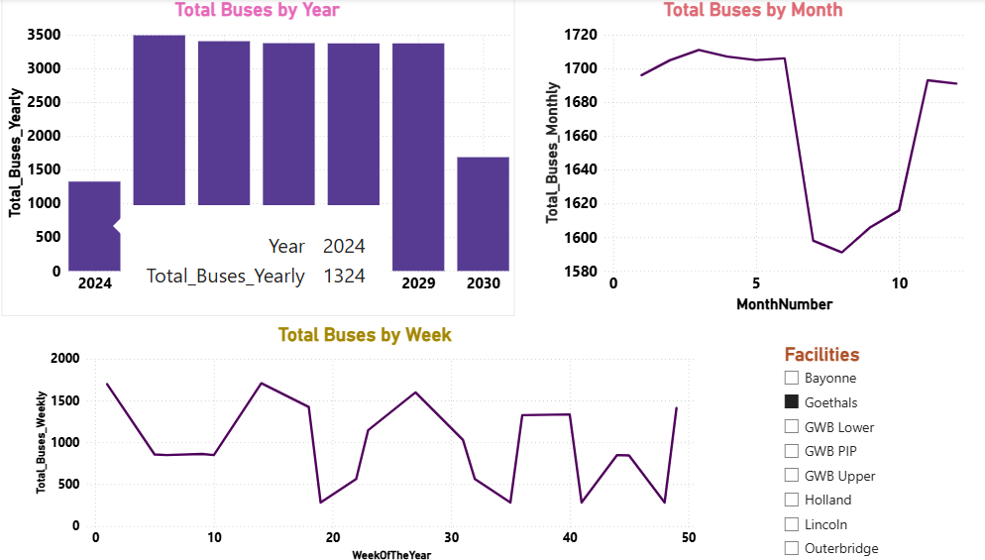

Forecasted Bus Traffic Trends Across Facilities (2025–2030)
The visual identifies weekly, monthly, and yearly patterns in bus volume, with forecasts showing peaks in early and mid-year weeks and a dip in late summer months. The ARIMA model helps predict facility-specific usage, aiding in proactive infrastructure and staffing decisions.

5: Comparison between current usage and pre-COVID (2019) :
Important Variables:
The key variables for comparing passenger usage are Year (2019 and 2023) and Total Passengers. These variables are essential to understand how travel patterns have changed since the pandemic. Including Monthly Aggregation helps identify whether the changes are consistent throughout the year or vary seasonally. Additionally, incorporating weekday vs. weekend indicators can reveal whether commuter patterns have shifted due to new working habits, such as increased remote work.
Dependent Variable:
The dependent variable in this analysis is Total Passengers, as we aim to quantify how the number of passengers has changed between the pre-pandemic period (2019) and the most recent data available (2023). This comparison is crucial to evaluate how passenger volumes have recovered post-COVID and whether ridership has returned to previous levels.
Recommendations:
To make accurate comparisons, it is essential to ensure that the data from both years is comparable by adjusting for any differences in data collection methods or service changes that may have occurred. Including contextual factors, such as government restrictions during the pandemic and shifts in public transport policies, can provide deeper insights into observed differences.
Models and Techniques:
We performed a comparative analysis between the two time periods, using statistical tests to validate differences in passenger count.
Tools Used:
Final Data is stored in excel, data cleaning and preprocessing is done in Power BI. The analysis was done using R, leveraging data visualization packages to compare trends and present the findings clearly. Power BI is used for dashboarding.

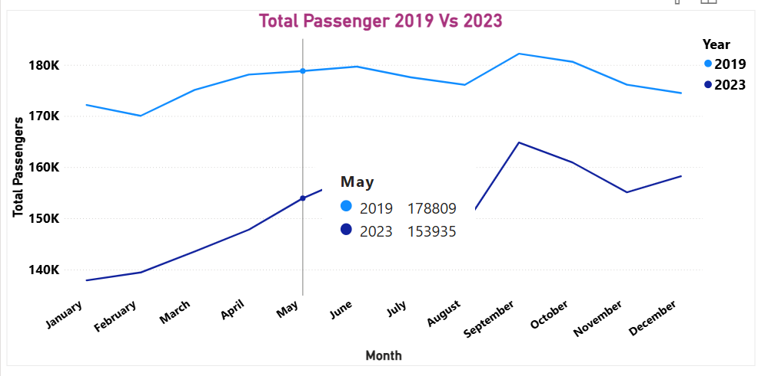

Monthly Passenger Trends: 2019 vs. 2023 (Pre- and Post-COVID Comparison)
Passenger volumes in 2023 remain consistently lower than in 2019 across all months, with the largest gaps observed during spring and early summer. The analysis highlights ongoing recovery challenges in public transit ridership post-COVID, influenced by behavioral shifts such as remote work.

